LEGO

Things to do:
- “Provide an example of a real-world organization that represents the new form of organizing of your choice and discuss how it functions”: Describe Lego
- “Identify how this real-world organization generates novel solutions to the universal problems of organizing”: What distinguishes lego from other toy-firms, and how it provides new solutions to the 4 (or one or some of them) organization problems
- “Identify strength, weaknesses, opportunities and threats (SWOT) associated to this particular organization / new form of organizing”

- Powerpoint
- Oral presentation

Structure presentation:
- Introduction
  - Brief overview of LEGO as a company
  - Importance of understanding its organizational model
- History of LEGO
  - Founding of the company
  - Evolution of LEGO products and brand identity
  - Milestones in the company's journey
- LEGO's Business Model
  - Explanation of LEGO's core business model
  - Revenue streams (e.g., sales of sets, licensing, merchandising, etc.)
  - Unique aspects of the LEGO business model
- Organizational Structure
  - Overview of LEGO's organizational hierarchy
  - Departments and divisions within the company
  - Matrix management structure (if applicable)
- Key Strategies
  - Product development and innovation
  - Marketing and brand management
  - Supply chain and manufacturing
  - Digital transformation initiatives
- Culture and Values
  - Discussion on LEGO's corporate culture
  - Emphasis on creativity, play, and learning
  - Importance of teamwork and collaboration
- Success Factors
  - Factors contributing to LEGO's success
  - Case studies or examples of successful initiatives
  - Competitive advantages in the toy industry
- Challenges and Solutions
  - Challenges faced by LEGO in the past and present
  - Strategies employed to overcome these challenges
  - Lessons learned and adaptations made
- Future Outlook
  - Growth prospects for LEGO
  - Emerging trends in the toy industry
  - LEGO's plans for innovation and expansion
- Conclusion
  - Recap of key points discussed
  - Importance of LEGO's organizational model in its success
  - Final thoughts on the significance of studying LEGO's organizational structure
- Q&A Session
  - Open the floor for questions and discussions

Which are the four organization problems?
The four common organizational problems typically include:
- Communication Issues: Problems in communication can lead to misunderstandings, lack of clarity, and inefficiencies. This includes issues such as poor feedback mechanisms, unclear directives, and ineffective channels for information flow.
- Conflict and Politics: Internal conflicts, power struggles, and office politics can hinder productivity and teamwork. When individuals or groups within an organization are in conflict, it can result in decreased morale, increased stress, and reduced collaboration.
- Lack of Alignment: When the goals and objectives of different departments or individuals within an organization are not aligned, it can lead to inefficiencies and missed opportunities. Lack of alignment can also result in conflicting priorities and wasted resources.
- Resistance to Change: Organizations that are resistant to change often struggle to adapt to new technologies, market conditions, or business strategies. This resistance can stem from various factors, including fear of the unknown, entrenched cultures, and reluctance to disrupt existing workflows.

LEGO: OVERVIEW AND HISTORY
https://www.officetimeline.com/blog/lego-history-timeline
https://www.lego.com/cdn/cs/aboutus/assets/blt4ee78e0776fce92f/LEGO_Company_Profile.pdf
https://changemanagementinsight.com/lego-change-management-case-study/

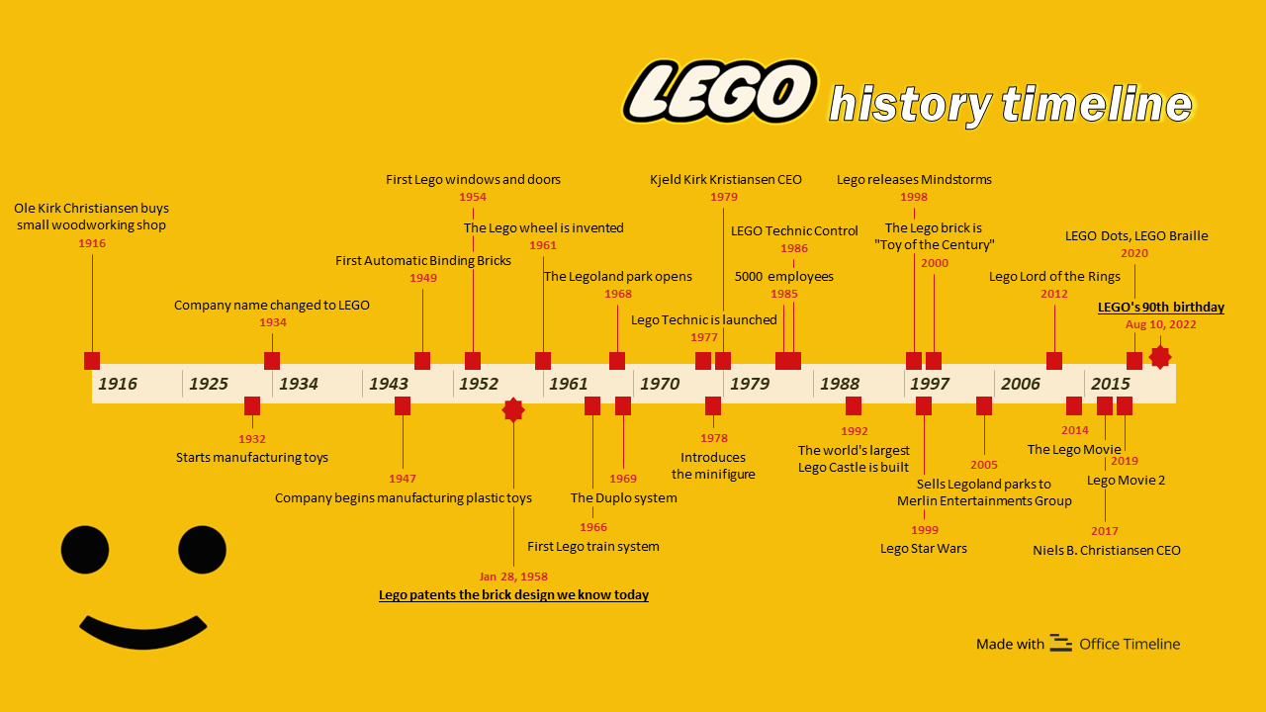

NB: this photo could be optimal for an entire slide at the start of the presentation (as a spoiler and a brief overview / introduction of the organization’s history)

OVERVIEW OF LEGO
LEGO is a Danish company founded in 1932, and it has become one of the most iconic toy manufacturers in the world. The company's name is derived from the Danish phrase "leg godt," meaning "play well."
Currently, LEGO stands as a global leader in the toy industry, continuing its legacy of creativity, innovation, and quality while adapting to the demands of the modern world. The company is implemented in over 140 countries and has expanded its reach through digital platforms, video games, mobile apps, and online communities. Additionally, LEGO has made significant strides in sustainability, aiming to use sustainable materials in its products and packaging. The company also operates LEGOLAND theme parks worldwide, offering immersive experiences.

IMPORTANCE OF UNDERSTANDING ITS ORGANIZATIONAL MODEL
However, in the late 90s and early 2000s, Lego experienced a significant decline in sales and profitability due to poor decision-making and failure to adapt to the changing market. To address these challenges, Lego had to undergo a significant transformation in its business model, manufacturing process, and organizational structure. This transformation was achieved through a successful “Change Management” strategy that involved collaboration, communication, and innovation.
These changes were efficient, as it led to a significant increase of Lego’s revenue following the implementation of changes. In 2020, the company reported revenue of $6.5 billion, up from $1.4 billion in 2004. Lego’s profitability also improved, with the company reporting a net profit of $1.6 billion in 2020, up from a loss of $300 million in 2004.

HISTORY OF LEGO
LEGO has a rich history dating back to its founding in 1932 by Ole Kirk Christiansen in Denmark. Initially, the company started as a small carpentry workshop where he crafted wooden toys, stepladders, and ironing boards.

Evolution of LEGO Products and Brand Identity:
- In 1949, LEGO introduced its first plastic toys, including the Automatic Binding Bricks, which laid the foundation for the modern LEGO brick system.
- The LEGO brick, with its interlocking design, was patented in 1958, revolutionizing the toy industry by giving the possibility of endless creations.
- Throughout the 1960s and 1970s, LEGO expanded its product line to include themed sets, widening their range of products.
- In 1978, the company introduced the iconic LEGO minifigure, a small articulated figure that became a staple in LEGO sets and played a significant role in the brand's identity.
- The 1980s saw the introduction of licensed LEGO sets based on popular franchises like Star Wars, Harry Potter, and Batman, further expanding the brand's appeal.
- LEGO continued to innovate with new technologies and product lines.
- In the 2000s and beyond, LEGO diversified its offerings with video games, movies, theme parks (LEGOLAND), educational products, and digital platforms, which reinforced its position as a leading global toy brand.

MILESTONES IN THE COMPANY'S JOURNEY
- LEGO patents the iconic brick design we know today in 1958
- By 1970, LEGO had 1,000 people working for them, with a capacity to produce large numbers of LEGO toys for children all over the world. This went along with the opening of manufacturing facilities in Europe, the United States, and other regions.
- In the late 1990s and early 2000s, LEGO faced financial challenges due to issues like overexpansion and competition from electronic toys. However, the company underwent a successful turnaround, refocusing on its core products and values.
- On August 10, 2022, the LEGO Group launched its biggest global advertising campaign because it celebrated its 90th Anniversary. The campaign is aimed to reinforce the importance of play in children’s growth and development.

Timeline?

- 1916: Ole Kirk Christiansen buys small woodworking shop (cf “history of lego”)

- 1979: Kjeld Kirk Kristiansen – CEO of the LEGO Group
In 1979, Kjeld Kirk Kristiansen becomes CEO of the LEGO Group. He is one of Ole Kirk Kristiansen’s grandchildren and the first in the family to hold a business degree.

- 2000: The LEGO brick named “Toy of the Century”
In 2000, the British Association of Toy Retailers (BATR) chose Lego as the winner of the BATR Toy of the Century awards. The brand broke through other competitors like the Teddy bear, Action Man and Barbie. LEGO was recognized for the major role it has played over the past century in the toys industry.

- 2022: 90 years of LEGO
The LEGO Group celebrated its 90th Anniversary with its first World Play Day.(cf “milestones”). The brand hosted a company-wide day where all employees got to experience “the power of learning through play.” This new tradition took place across all Lego factories, stores, and offices around the world. Special activities were also available in the Legoland parks. The event was promoted online and Lego collaborated with various companies and stars to celebrate this special moment.

LEGO BUSINESS MODEL
- LEGO's Business Model
  - Explanation of LEGO's core business model
  - Revenue streams (e.g., sales of sets, licensing, merchandising, etc.)
  - Unique aspects of the LEGO business model
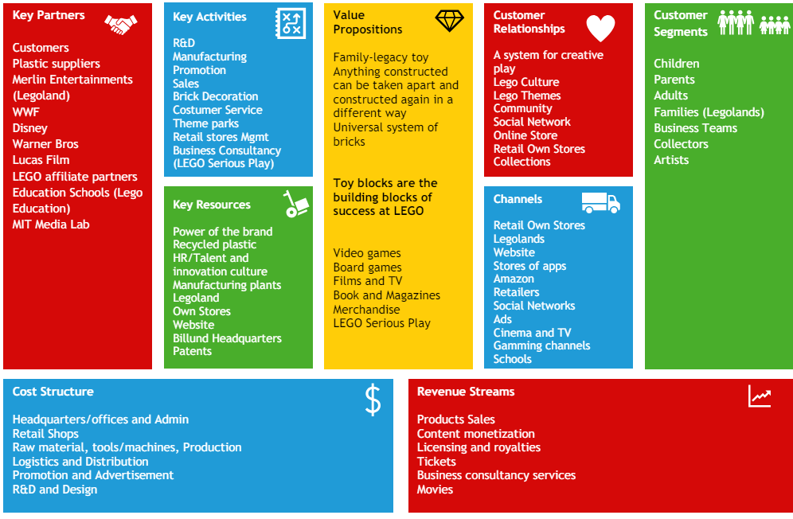

CORE BUSINESS MODEL
LEGO Group is a very successful toy production company, with a successful business model and ability to take on new profitable opportunities and improve.
Its market value increased from $5.4 bln in 2015, to approximately $13 bln in 2023.
Its success allows it to reap outstanding profits: in 2023 the year closed with DKK 65.9 billion ($ 9,52 bln ) revenues, and DKK 17.1 billion ($ 2.47 bln) in operating profit.
The revenues are the result of a vast differentiation in offer and a big market share. More details later on,

LEGO® Group is present in more than 130 countries, owns more than 570 stores and 5 manufacturing plants.
The business can be summarized as follows:
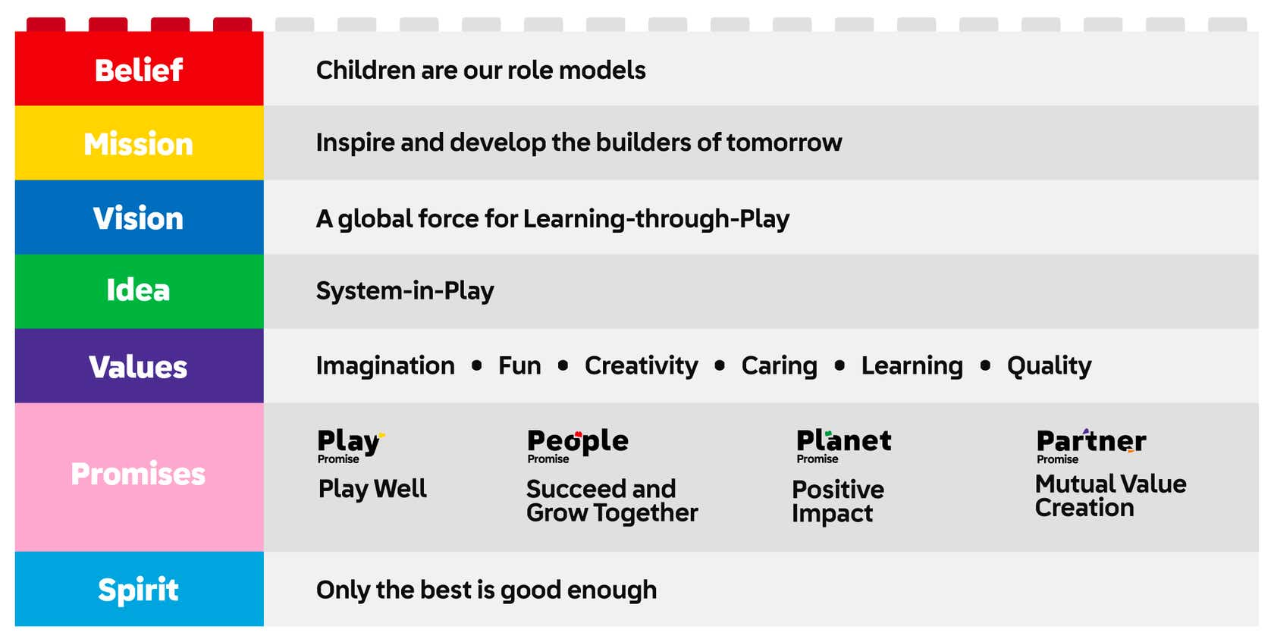
Lego’s commitment to remaining privately owned allows the company to focus on its long-term vision and values, without the short-term pressures often associated with public ownership. This has enabled it to maintain its status as a global leader in the toy industry while staying true to its core principles of creativity, quality, and learning through play

KEY STRATEGIES
Its success is based on these key strategies:
- QUALITY: Lego has built the reputation of offering durable and safe toys, focusing also on the highest playability standards.
- BRAND IDENTITY: Lego’s has managed to transmit to people the link between its brand and its key values: imagination, fun, creativity, caring, learning and quality.
- GLOBAL REACH:LEGO is present in more than 130 countries thanks to its variety in the distribution channels. To attract customers from different countries, it adapts to local preferences and cultural nuances
- PARTNERSHIPS and COLLABORATIONS: LEGO has found that making strategic partnerships and collaborations with popular entertainment franchises is a great way to increase revenues.
It brings excitement to its already customers, and attracts new ones.
Some popular collaborations are: Disney, Warner Bros, Universal Studios.
- SUSTAINABILITY AND ENVIRONMENTAL RESPONSIBILITY: With the rise in awareness over environmental issues, sustainability has become a key goal for companies. A recent study led by CGS, shows that 68% of consumers rate sustainability as an important factor when making a purchase.
LEGO puts importance to both environmental sustainability, for example it is committed to reduce carbon footprint, use renewable energy sources, eco-friendly packaging.
But also to sustainability in a sense of leaving a good impact on the community and treating its workers fairly.
In this way their brand resonates with conscious consumers
- DIGITAL INNOVATION: With the introduction of digital elements, it managed to survive and thrive in the changing market of play. It developed video games, mobile apps, augmented reality experiences and also films

REVENUE STREAMS
Lego has had a trend for increasing revenues.
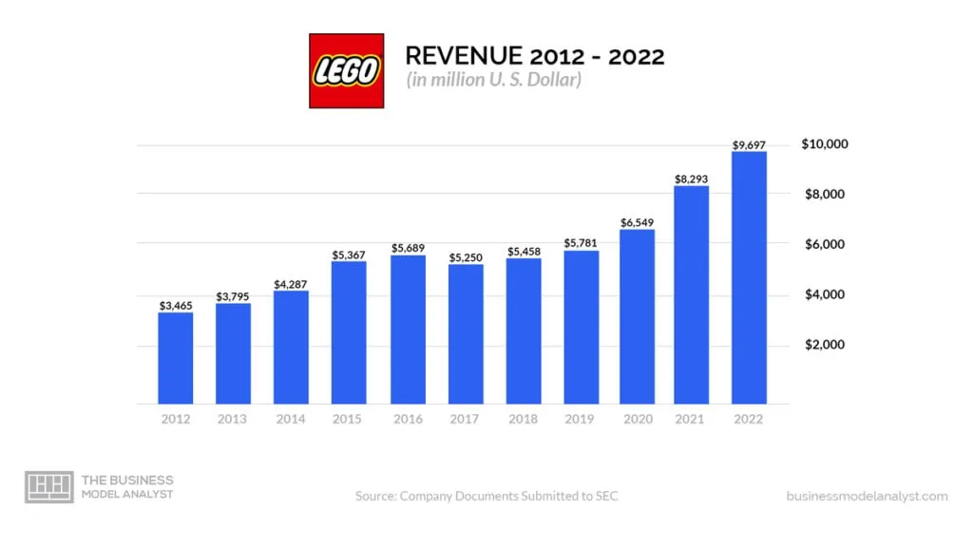

They generate their revenue through:
- PRODUCT SALES: Primary revenue stream. Extensive product portfolio and wide customer base.
- LICENSING AND PARTNERSHIPS: These collaborations allow Lego to create specialized sets based on movies, TV shows, video games, and other intellectual properties
- THEME PARKS AND EXPERIENCES: Example Legoland and Legoland Discovery Centers. Revenues from ticket sales, merchandise, food and beverage sales contribute to revenue
- DIGITAL GAMES AND MEDIA: Video games, lego-themed, animated movies, TV shows, web series. Revenue from sale of these products and licensing fees and partnership with media platforms
- EDUCATION AND LEARNING SOLUTIONS: Promotes learning through play sets used in school and educational institutions to enhance STEM education.
Their customers can be grouped in these categories:
- Children: highest section
- Adult hobbyist, usually collect most intricate sets and focus on expert-level creations, large-scale models, architectural sets
- Parents and gift buyers: because they have a wide range of sets, from affordable to intricate choices
- Educators
- Retailers and distributors

MARKETING
Of course to successfully sell the products and retain customers, a good marketing is needed.
- Iconic partnerships
- User generated content: Lego actively encourages users to generate content, and submit their own designs.
This fosters a sense of ownership and excitement in the client’s mind.
Nevertheless it contributes to innovation
- Immersive brand experience, for all ages, such as Legoland and interactive stores.
Helps to deepen emotional connection with customers
- Emotional storytelling: use “heartwarming” commercials and campaign, and storytelling competitions to tap on nostalgia and reminding customers of the joy of the brand
- Engaging digital campaigns: example building challenges
- strong partnerships with educational sector
- Pricing strategy: strikes a balance between value and perceived quality.
It has an higher price tag that reflects the quality and the craftsmanship
- Strong presence in social media platforms

COST STRUCTURE
Lego’s cost structure consists of:
- Raw material costs
- Manufacturing costs
- Research and development expenses
- Marketing and advertising expenses
- Distribution and logistics costs
- Licensing fees
- Administrative and operational expenses
- Customer support costs

LEGO 2000s MANAGERIAL CHANGE
https://knowledge.wharton.upenn.edu/article/innovation-almost-bankrupted-lego-until-it-rebuilt-with-a-better-blueprint/
https://www.cfocentre.com/us/true-toy-story-legos-incredible-turnaround-tale-2/

Revenues haven’t always been so flourishing. Indeed between 1990 and 2000 Lego almost went bankrupt.
By 2003, the company was virtually out of cash. It lost $300 million that year, and the projected loss for the next year was up to $400 million.
To get out from this they learned that innovation is key, but it has to have a specific direction.
Indeed they already had a lot of creativity and had expanded a lot of the range of products offered, but they found out later that only a few of their creative ideas were actually making money.
Actually at the time the company had no idea which products were making money.
Even the success of the Harry Potter line wasn’t enough to cover the losses made by that point.
The company had yet to answer these basic questions:
“Where do you want to go?”, “Where are you now?” and “How will you get there?”
SOLUTIONS
To solve the issue, the former CEO Kirk Christianses left the chair to Knudstorp.
With the help of Finance Director Jesper Oveson (former Chief Financial Officer of one of the largest banks in Scandinavia, the Danske Bank), Knudstorp began to make sweeping changes.

Some of the key issues identified were:
- inadequate degree of financial analysis
- profit and loss by country but not by product => no product analysis and profitability of lines
- theme parks were a cash drain, but they didn’t know why

Some of the key solutions:
- Setting financial targets. Ovesen introduced a near-term, measurable goal of 13.5% return on sales benchmark and established a financial tracking system—the Consumer Product Profitability system. It measured the return on sales of individual products and markets so the company could track where it was making and losing money. Every existing or proposed product had to demonstrate it could meet or surpass that benchmark.
- Cost-cutting (including cutting 1,000 jobs)
- Improving processes (many processes were outsourced which meant employee numbers could be cut by another 3,500)
- Managing cash flow
- Introducing performance-related pay
- Reducing the product-to-market time.
- Selling the theme parks and slowing retail expansion.
- Cutting the number of components from almost 7,000 down to about 3,000
All of this allowed Lego to survive this period of crisis and go back on track stronger than before

LEGO AGILE TRANSFORMATION
https://www.dockconsulting.nl/wp-content/uploads/2021/03/Agile-at-Lego.pdf

INTRO
Lego group noticed that the modern environment is one where innovation and ability to adapt quickly to changes is an essential skill.
They were already aware of this, and have become aware of the substantial obstacles they had in the product development procedures: compartmentalized teams, disjointed planning efforts and lack of unity in executing large scale projects.
That’s also why they have developed an interest in the agile method of leading an organization.
Some of the principles taught from the agile method were already in use at Lego.
But the real change was made in 2018, when they launched an Agile transformation of the corporate digital departments.
The benefit they were seeking to obtain, was to increase their responsiveness in both IT and product development. And indeed they have obtained many benefits.
What is the agile model?
Any so-called “agile processes' ' adheres to the Agile Manifesto ( Beck et al. 2001). The Agile Manifesto is not a methodology, but rather a mind-set, a way of thinking that supports certain behaviors. The Manifesto is a list of 12 principles, which emphasize customer engagement, flexibility, collaboration, and rapid delivery of working products.
The agile methodology branched out into different types to best suit the end goals.
The form that LEGO choose is “Agile scrum methodology”. The main goal of scrum is to improve communication, teamwork and speed of development.

CHANGES TO TAKE
When an organization wants to transition to the agile model, there are some key changes that they should make.
The changes affect these areas:
:
- Organizational structure: the company should evolve from existing structure (such as functional or matrix) to a product-oriented team structure.
- Mandate: the company has to shift the mandate and responsibility of results from managers, to product teams.
- Financial processes: the firm should move from traditional yearly budgeting processes (fixed) to frame-based dynamic budgeting (venture-capital style) based on strategic aims.
- Performance measures: should apply new ways to evaluate performance. This should include measuring success based on value measures, product measures and team measures. These measures have to replace the traditional key performance indicators (KPIs) which usually focus on measuring the degree of process adherence

Lego successfully implemented all of these changes.
Management approach also must be reconsidered when adhering to the agile model.
The question to be answered is: how should the company effectively introduce and implement changes in the company?
More specifically, how should managers implement an agile transformation in the company? Remember that an agile transformation implies adopting a mindset, rather than a clear defined set of instructions.
The traditional ways in which a change is implemented are called:: top-down change management approach and bottom-down change management approach.
A top-down change implies that the details of what needs to change are decided by leaders and imposed on employees
A bottom-up change occurs when employees decide themselves to change behavior and that change reshapes the organization.
In the context of a structural change to transition to an agile model, neither approach can work. Why?
Top-down change which is about telling employees exactly what they should do, is against the agile principles. Leaders should empower workers and not merely give them orders. Additionally it could create “change-fatigue” among the employees.
The second approach instead lacks strategic direction and could end up in employees deviating from the company’s goals and challenging their leaders’ status.
The best approach to transition to an agile model, is to follow the Open- change theory, which offers a middle-way of the other 2 alternatives,
Based on the Open-Source change strategy, the company calls employees to make a change for the benefit company. With this strategy employees Co-Create change decisions; they own implementation planning; they talk openly about the change.
The use of this sOpen-source change strategy has many benefits.
Gartner’s 2023 HR Priorities states that some of the pros are:

- Change success is 14x times more likely.
- The risk of change fatigue drops by as much as 29 percentage points.
- Intent to stay increases by as much as 19 percentage points
- Employees are 1.5x more likely to be willing to change.
Also this approach reduces the time it takes to successfully introduce a change, because employees have more decisional autonomy and are proactive in the implementation process. So they don’t have to wait for a leader to tell them what they should do.
So also Lego chose to apply this strategy.

LEGO STRATEGY
Lego, to be successful at the technique of the Open-source change, developed its own strategy.
For the first 100 days they have taken care of training, proactive knowledge sharing, leadership and people processes, and value management.

- Training included Agile basic training, Scrum master training, product owner training, Agile leadership training, and Agile coach training.
- Knowledge sharing included social media activities; Agile hub activities; self-organized Agile networks for Scrum masters and product owners, called guilds; and biweekly Agile meetings with specific topics or guest speakers.
- Leadership and people processes included exploring the need for new job structures and leadership processes. This work is still ongoing in the second half of 2018, as the company adjusts structures to make Agile roles attractive and relevant to the right people and to ensure all members have an appropriate mandate, for instance, that product owners really have full product responsibility including, for example, financial responsibility.
- The value management stream focused on establishing product definitions and new performance management structures.
Lego established an agile transformation team, which took a central role in supporting and guiding the transformation.
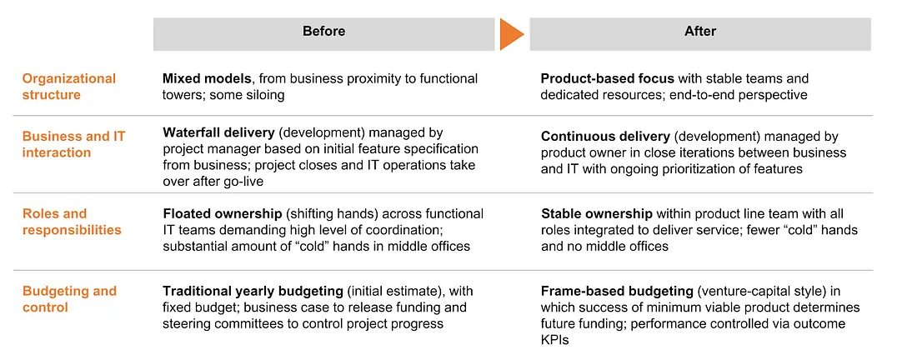
Of course lego also made the general changes needed when doing an agile transformation:

RESULTS

As a whole, the data show that LEGO’s Agile transformation, using the open-source change approach to implement
Agile across all five categories of transformation, was successful in creating a product-oriented team structure with
team ownership of deliverables, frame-based budgeting, value product and team measures, and continuous value
delivery in iterations
Also LEGO found that they increased speed to market, product quality, team productivity and team motivation.

A success story they have reported is the following:
Developing a finance product in just two sprints:
The finance department had requested a specific product, estimated to require 8,000 hours of development time, under the traditional project portfolio. Due to central prioritization,
the business case was never approved. Once the Agile transformation shifted prioritization mandate to the
the finance team’s product owner, the product was made a top priority. The team developed and demonstrated a minimum
viable product in just two sprints—four weeks, and less than 800 hours—one-tenth of the originally estimated
8,000 hours.

CHALLENGES and WEAKNESSES
The agile methodology sounds great, but nevertheless it brings some challenges and weaknesses.
In the LEGO transformation case, they’ve found that:
- understanding how leaders can best support employees without interfering too much, to respect the open-source change theory can be challenging
- certain teams found the agile method is not needed and doesn’t make the work procedure more efficient.
The teams which struggled seemed to be those whose members had a diverse set of individual responsibilities to a broad range of customers.
And this is fine, because indeed the agile method wasn’t forced on teams. Instead teams were invited to reflect which methodology of work could be most efficient for the project
https://ccaps.umn.edu/story/agile-methodology-advantages-and-disadvantages
https://projectmanagers.net/top-10-cons-or-disadvantages-of-agile-methodology/
Some general disadvantages of the agile methodology are that:
- Less predictable. The flexibility at the core of the Agile method also means a much lower degree of predictability. It can be much more difficult to accurately estimate the time necessary or quantify the resources and efforts required to complete a project. Many teams fear this uncertainty, and that fear can lead to frustration and poor decision-making.
- More time and commitment. Communication and collaboration is great, but that constant interaction takes more time and energy for everyone involved.
Additionally agile methodologies often emphasize individual performance and autonomy. This can pressure team members and lead to burnout or decreased morale.
- Team dependency: Highly skilled team members with expertise and self-management skills are required. Finding such skilled members can be challenging and less experience members can suffer.
Also there is a dependency on the team members, and if one leaves the team this could disrupt the workflow.
Another point with regards to teams, is that team dynamics can heavily influence the outcome of a project.
- Projects easily fall off track. The less-structured nature of Agile Methodology means projects can easily go astray or run beyond the original scope of the project.
- Unpredictable Budgeting: Agile’s flexible and dynamic nature can lead to difficulties in predicting and controlling project costs, potentially resulting in budget overruns.

LEGO ORGANIZATIONAL STRUCTURE
The LEGO Group's organizational structure consists of an Executive Leadership Team comprising seven members and a Board of Directors. The Executive Leadership Team includes Niels B. Christiansen as the Chief Executive Officer, Atul Bhardwaj as the Chief Digital & Technology Officer, Carsten Rasmussen as the Chief Operations Officer, Colette Burke as the Chief Commercial Officer, Jesper Andersen as the Chief Financial Officer, Julia Goldin as the Chief Product & Marketing Officer, and Loren I. Shuster as the Chief People Officer. The Board of Directors is led by Thomas Kirk Kristiansen as the Chairman and Søren Thorup Sørensen as the Vice Chairman, along with other members like Anne Sweeney, Ebi Atawodi, Fiona Dawson, Ilkka Paananen, Jan Thorsgaard Nielsen, and Jørgen Vig Knudstorp.

Lego's organizational structure underwent significant changes to focus on its core business operations, transitioning from a single unit to a conglomerate with several independent units. This restructuring involved horizontal expansion with divisions for each product but vertical narrowing to reduce layers between bottom and top management. Each division became fully responsible for profits and results, fostering accountability and autonomy within the organization. This shift towards a more collaborative and customer-centric approach, along with brand expansion beyond traditional building sets, contributed to Lego's successful transformation and significant positive outcomes, including increased revenue, improved profitability, expanded market share, and a strong brand identity.

(I have to add the part about LEGO serious play, so how the structure changed in the 2000s, and why it worked)

Success Factors of LEGO – Why is LEGO considered so iconic?
LEGO has captured the hearts and minds of generations worldwide. Since its humble beginnings in 1932, LEGO has become an iconic brand, celebrated for its timeless appeal, unparalleled creativity, and enduring legacy. In this article, we delve into the reasons behind LEGO’s iconic status, exploring how the brand’s commitment to quality, innovation, educational value, and imaginative play has solidified its place in the hearts of children and adults alike.
Quality and Durability: One of the key factors contributing to LEGO’s iconic status is its unwavering commitment to quality. LEGO sets are renowned for their durability, precision, and meticulous attention to detail. The brand’s dedication to using high-quality materials ensures that LEGO bricks can be assembled, disassembled, and reassembled countless times without compromising their structural integrity. This focus on durability has allowed LEGO creations to withstand the test of time, passing down from one generation to the next, fostering a sense of nostalgia and continuity.
Endless Creative Possibilities: LEGO’s iconic status stems from its ability to unlock boundless creativity. The brand’s interlocking brick system provides an infinite universe of possibilities for imaginative play and construction. LEGO sets are designed to encourage open-ended exploration and problem-solving, allowing builders to bring their unique ideas to life. The versatility of LEGO bricks empowers individuals to build structures, vehicles, characters, and entire worlds limited only by their imagination. This freedom of expression and creative empowerment has made LEGO a timeless favorite for builders of all ages.
Educational Value: LEGO’s impact extends beyond play; it also holds significant educational value. The brand seamlessly integrates learning with fun, fostering cognitive development, spatial awareness, fine motor skills, and logical thinking. LEGO sets promote critical thinking and problem-solving as builders navigate through instructions, devise solutions, and experiment with different building techniques. Additionally, LEGO’s educational product lines, such as LEGO Education, provide specialized sets and programs that facilitate learning in classrooms, promoting STEM concepts, teamwork, and creativity.
Universally Appealing Themes: LEGO’s success lies in its ability to adapt to evolving trends and embrace a wide range of themes. From classic LEGO City and LEGO Castle sets to popular licensed themes like LEGO Star Wars and LEGO Harry Potter, LEGO offers a diverse range of sets that cater to various interests and fandoms. By tapping into universally beloved franchises and introducing new and exciting themes, LEGO remains relevant and resonates with both children and adult fans, fostering a sense of connection and engagement.
Engaging Community and Collaborations: LEGO’s iconic status is also attributed to its vibrant community of builders and enthusiasts. LEGO fans, known as AFOLs (Adult Fans of LEGO), form a passionate and dedicated community that celebrates the brand’s creativity and craftsmanship. LEGO actively engages with its community through online platforms, events, and fan conventions, fostering a sense of belonging and shared enthusiasm. Moreover, LEGO collaborates with external partners and franchises to create special edition sets, promoting cross-brand collaborations that ignite excitement among fans and collectors.
Design Excellence: LEGO’s iconic status can be attributed to its impeccable design. The brand invests considerable effort in creating aesthetically pleasing and functional sets. LEGO designers meticulously craft each brick, ensuring precision, compatibility, and ease of use. The attention to detail extends beyond the bricks themselves to encompass the packaging, instructions, and overall presentation, enhancing the overall user experience. LEGO’s commitment to design excellence ensures that every set captures the imagination and delivers a satisfying building experience.
Cross-Generational Appeal: LEGO’s enduring appeal lies in its ability to transcend generations. It is a brand that resonates with both children and adults. Many adults fondly recall their childhood experiences with LEGO, fostering a sense of nostalgia that often leads to continued engagement with the brand. LEGO’s ability to create sets that appeal to different age groups, from DUPLO for toddlers to complex Technic sets for advanced builders, ensures that there is something for everyone, regardless of their age or skill level.
Licensing and Partnerships: LEGO’s strategic partnerships with popular franchises, movies, and brands have played a significant role in its iconic status. Collaborations with franchises like Star Wars, Marvel, Harry Potter, and Disney have resulted in LEGO sets that bring beloved characters and scenes to life. These licensed sets tap into the fan bases of these franchises, combining the appeal of both LEGO and the licensed property, and creating a powerful synergy that resonates with fans around the world.
Innovative Marketing and Branding: LEGO’s marketing efforts have been instrumental in solidifying its iconic status. The brand’s advertising campaigns often emphasize the imaginative play and creative possibilities that LEGO offers. LEGO commercials and print advertisements showcase the joy of building, the limitless potential of LEGO bricks, and the sense of accomplishment that comes with completing a set. LEGO’s consistent branding, recognizable logo, and iconic minifigures have become synonymous with the brand, further contributing to its iconic status.
Global Reach and Distribution: LEGO’s global distribution network is another key aspect of its success. The brand has a presence in over 140 countries, making its products widely accessible to consumers worldwide. LEGO sets are available in toy stores, department stores, and online retailers, ensuring that people from diverse backgrounds can experience the joy of LEGO. The brand’s global reach has enabled it to become a household name and foster a global community of LEGO enthusiasts.
Continuous Innovation: LEGO’s commitment to innovation has been instrumental in its iconic status. The brand continually introduces new elements, building techniques, and play experiences to keep its offerings fresh and exciting. From introducing advanced motorized functions in Technic sets to incorporating augmented reality and interactive elements in LEGO sets, the brand embraces technology and trends to enhance the LEGO experience. This dedication to innovation ensures that LEGO remains relevant in a rapidly evolving toy industry.
In conclusion, LEGO’s iconic status is a culmination of factors such as its commitment to quality, endless creative possibilities, cross-generational appeal, strategic partnerships, innovative marketing, global reach, and continuous innovation. Through these efforts, LEGO has built a brand that fosters imagination, encourages learning, and brings joy to millions of individuals worldwide, solidifying its position as an iconic and beloved toy brand.

SWOT ANALYSIS
Strengths:
1. Strong Brand: LEGO has a strong global presence with products sold in over 130 countries, and it has 570 branded stores worldwide.
2. Creativity & LEGO community: LEGO has a platform called LEGO Ideas that promotes fan engagement, allows fans to submit product ideas, and hosts activities.
3. Product Quality and Innovation: LEGO is known for its high-quality products that are built to last, and the company continually invests in research and development, moreover LEGO continually refreshes 60% of its product catalog every year, keeping children excited about new sets and products.
4. Long-term experience of market: LEGO has a long history of success in the toy market, having been founded in 1932.
5. Strong relationship with suppliers & distributors: The LEGO Group fosters strong relationships with its suppliers and distributors by requiring them to adhere to the LEGO 12 Responsible Business Principles (related to ethics, people, children and the environment.
6. Strong ecommerce & LEGO movies franchise: LEGO has a strong ecommerce presence. LEGO grew its online sales by about 10.5% in 2022. The Lego franchise in movies has been an important contributor: the first film, "The Lego Movie," in 2014, significantly boosted the company's sales and profits.

Weaknesses:
1. High Pricing: LEGO's products are often considered luxury items due to their higher price compared to competing building toys, which can discourage budget-conscious shoppers.
2. Dependence on Plastic: LEGO's reliance on plastic as a primary material for its products can be a concern in the face of growing environmental awareness and the need for sustainable practices.
3. Lack of Innovative capability and agility compared digital toys: The company's traditional focus on physical toys has led to a slower adoption of digital technologies. This is evident in the company's initial reluctance to fully integrate digital elements into its products.
4. Cost of material: The cost of producing one LEGO brick is approximately $0.0046. This cost is derived from the price of ABS plastic. However, the overall production cost of LEGO bricks increases significantly when factoring in labor, transportation, quality control, and other production expenses.

Opportunities:
1. Entering New Geographies: LEGO can expand its reach into new markets and regions, potentially increasing its customer base and revenue.
2. Digital Integration: LEGO can leverage digital technologies to enhance its products and services, such as through video games, mobile apps, and online platforms.
3. Sustainability Efforts: LEGO can capitalize on the growing demand for sustainable products by investing in renewable energy sources and reducing its environmental footprint.
4. Partnerships and Collaborations: LEGO can explore partnerships with other companies, organizations, or educational institutions to expand its offerings and reach new audiences. Development of regional partnerships to create tailored toys

Threats:
1. Intense Competition: LEGO faces stiff competition from other toy manufacturers and digital entertainment options, which can impact its market share and sales. The main competitors of LEGO are Mattel, Hasbro, Spin Master, and Bandai Namco, all of which are large toy corporations that produce popular toys like Barbie, Hot Wheels, Transformers, and Gundam models.
2. Counterfeit Concerns: The widespread popularity of LEGO products makes them vulnerable to counterfeiting, which can damage the brand's reputation and revenue.
3. Financial Fluctuations: LEGO, like any other business, is susceptible to financial fluctuations and market changes, which can impact its profitability and growth.

Strategy Strengths-Opportunities:
1. Brand Consistency: Ensure that all marketing efforts, partnerships, and sustainability initiatives align with the LEGO brand values and messaging.
2. Innovation: Continuously invest in research and development to stay ahead of the competition and maintain product quality & innovation.
3. Community Engagement: Foster a strong sense of community by engaging with customers, influencers, and partners through social media, content creation, and events.
4. Supply Chain Optimization: Maintain strong relationships with suppliers & distributors to ensure efficient and sustainable supply chain operations.

Strategy Weaknesses-Opportunities:
1. Diversify product offerings and materials: The LEGO Group has been successful in diversifying its product offerings and materials to cater to a broader range of customers and preferences. Additionally, LEGO has expanded its product lines to include digital products like video games and mobile apps, further enhancing its digital presence. This diversification has allowed LEGO to maintain its market share and appeal to a wider audience.
2. Enhance digital presence and integration: LEGO has made significant strides in enhancing its digital presence and integration across various platforms. The development of digital tools like LEGO Digital Designer, which allows users to design and build digital models, and the integration of augmented reality (AR). The company has also invested heavily in social media and e-commerce platforms to engage with customers and provide a seamless shopping experience.
3. Optimize operations and supply chain management: LEGO has been actively working to optimize its operations and supply chain management to improve efficiency and reduce costs. The company has also outsourced some of its operations to third-party logistics providers like DHL Supply Chain, which has helped reduce complexity and costs.
4. Expand into new geographies and markets: LEGO has been expanding its presence into new geographies and markets to increase its global reach and customer base. The company has also been investing in e-commerce platforms and digital marketing initiatives to target new markets and customer segments.

Strategy Strengths-Threats:
1. Differentiate through Innovation: Focus on innovation and product quality to differentiate Lego from competitors and maintain customer loyalty.
2. Engage the Community: Engage the community through social media and online platforms to foster a sense of belonging and encourage user-generated content.
3. Diversify Revenue Streams: Expand the e-commerce platform and leverage the franchise to create additional revenue streams through licensing and merchandising.
4. Strengthen Supply Chain: Strengthen relationships with suppliers and distributors to ensure a stable supply chain and reduce dependence on a single supplier or distributor.
Strategy Weaknesses-Threats:

Address high pricing: Conduct market research to identify the optimal pricing strategy that balances revenue goals with customer affordability and demand. Consider offering tiered pricing options or promotions to make the products more competitive in the market. Develop a premium product line with unique features to justify higher prices and differentiate from competitors.

Mitigate dependence on plastic new materials: Explore alternative materials and sustainable options for toy production, such as bioplastics, recycled materials, or eco-friendly packaging.

Diversify revenue streams & develop an emergency fund: LEGO's primary revenue stream comes from the sale of its iconic building sets and individual bricks. However, to reduce reliance on this single source of income, the company should consider expanding into new markets and products (e.g. licensing & partnerships, digital ventures, education & training, merchandise & accessories and experience & events).

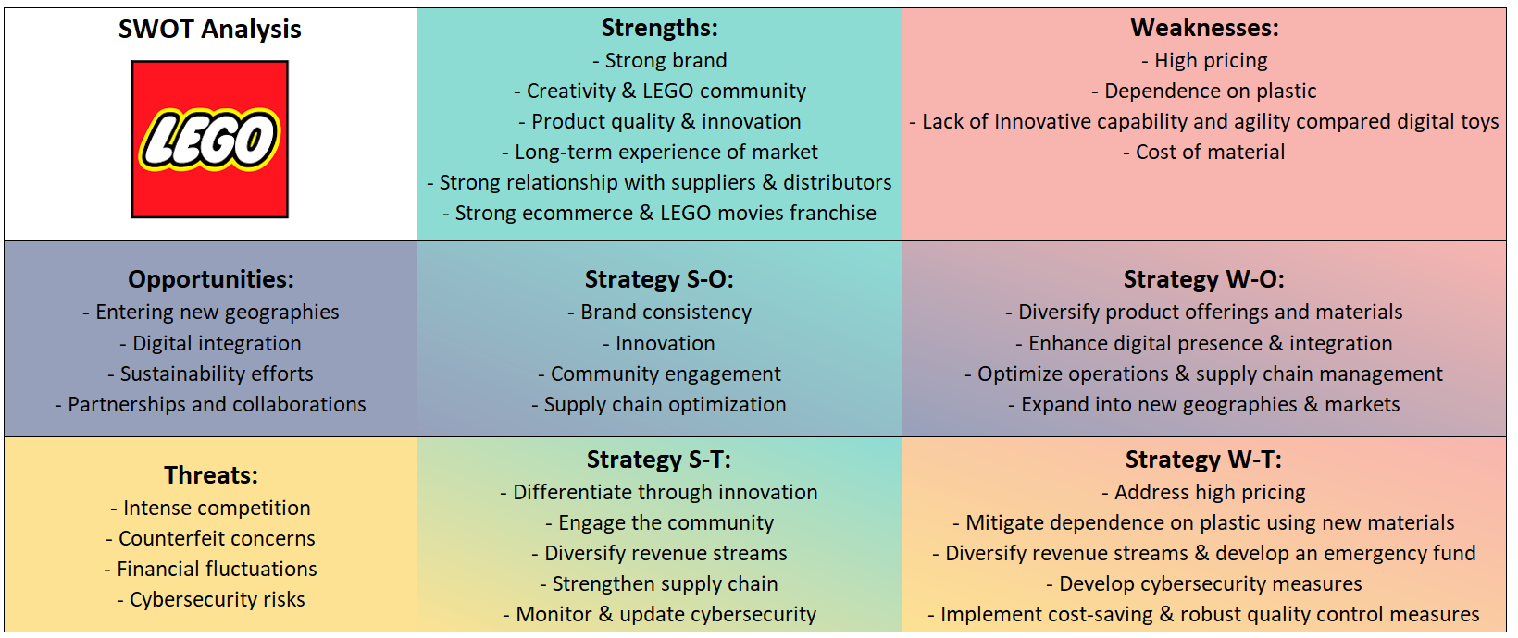
Implement cost-saving & robust quality measures: The LEGO Group has been actively implementing cost-saving and robust quality measures across its operations. These measures are crucial in ensuring the company's commitment to sustainability while maintaining its high-quality products. Here are some key initiatives: quality control, packaging efficiency, manufacturing process, environmental efforts, partnerships and cost savings.

The LEGO® SERIOUS PLAY® (LSP) method was developed by LEGO® in the mid-1990s as a response to a crucial challenge: the company's own survival. Initially conceived solely as a training methodology to support and assist internal organizational strategy, it later became a well-known and widely used method for enhancing human capital worldwide.
This is a methodology that facilitates and "accelerates" rational, decision-making, communicative processes, and problem-solving techniques within organizations and work groups;the LEGO® SERIOUS PLAY® method stands out clearly as a "democratic method" that ensures total participation in the discussion topic. This is because the method starts from the basic conviction that every person must have the opportunity to make an individual contribution.
This method uses LEGO bricks for creative problem-solving and communication. It is a hands-on, innovative approach that allows participants to express their thoughts and ideas through building with LEGO bricks.
The most important features of this method are:
- Improves organizations, teams, and individuals through conflict resolution, defining individual and group identity, and actively developing strategic business planning;
- Smooths differences by overcoming diversity and interpersonal barriers and turning them in favor of the group;
- Solves complex problems in dynamic contexts by facilitating the transition from a chaotic state to a more defined one, involving everyone actively;
- Innovative Solutions: The methodology stimulates creativity and innovation, leading to the generation of unique and out-of-the-box solutions.
It is precisely because of the value placed on everyone's contribution that people and organizations benefit in terms of greater understanding and clarity of problems.
LEGO Serious Play has been widely used in various settings, including team-building workshops, strategy development sessions, and organizational change initiatives, to unlock creativity, improve communication, and drive meaningful change.

